**CSE523 Machine Learning**

**Heart Attack Prediction**

| **Group Members** | **Roll No** |
| --- | --- |
| **Shivam Thakker** | **AU1940193** |
| **Devarsh Sheth** | **AU1940189** |
| **Pranav Gandhi** | **AU1940313** |
| **Meet Jhaveri** | **AU1940284** |

**Group-3 Weekly Report-7**

* As per the remarks given by sir for our dataset, we had a small dataset. We thought of generating data but then thought it wouldn't be a good idea.
* So after putting in some efforts we found 2 more datasets that set our features.
* 1 dataset we found from kaggle has 912 rows and the other dataset we found was from data world which had around 300 rows. The 2 datasets are mentioned below:

Dataset link :

<https://data.world/informatics-edu/heart-disease-prediction>

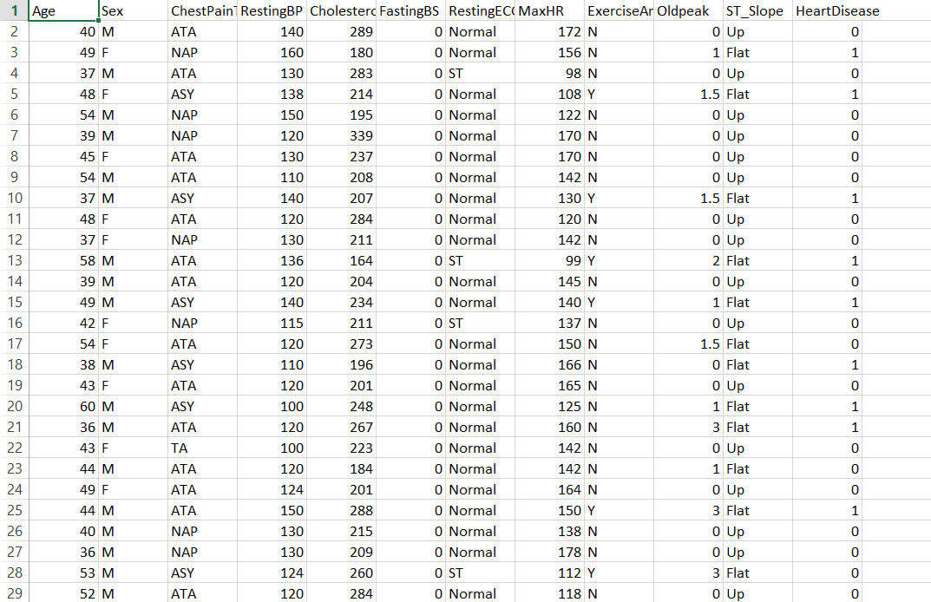

* There are total of 12 Features such as age, sex, chest pain, Resting BP, ChestPain, Resting ECG, Cholesterol etc, and 270 rows.
* The data contain both the categorical and the numerical feature in it.

Dataset link :

<https://www.kaggle.com/datasets/fedesoriano/heart-failure-prediction>

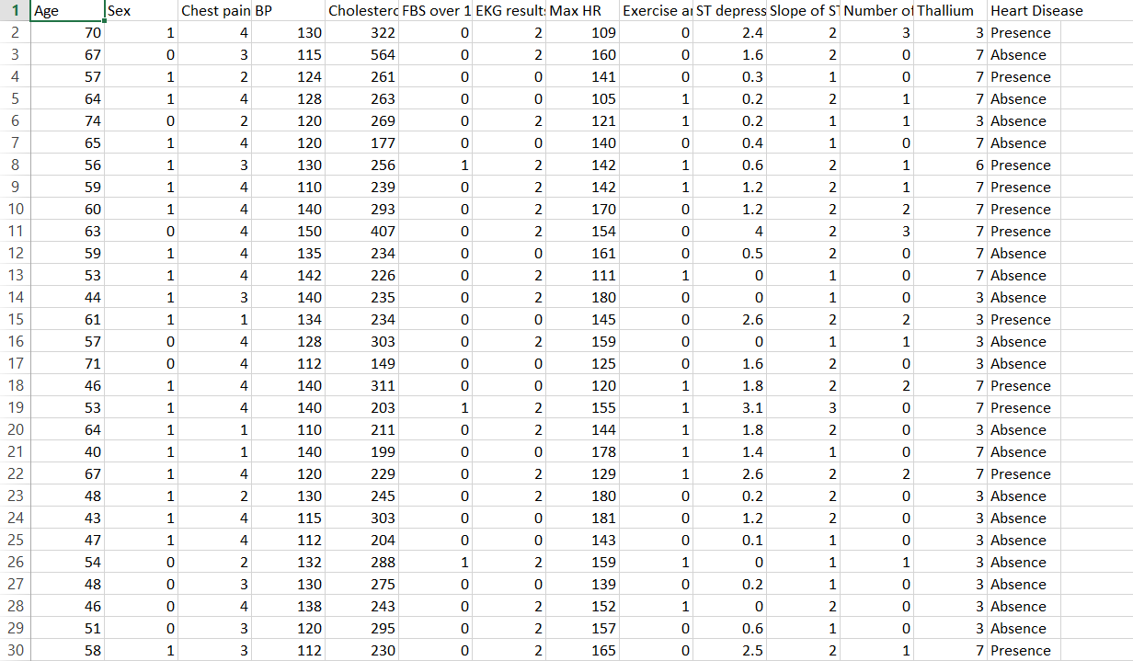

* There are total of 14 Features such as age, sex, chest pain, Resting BP, ChestPain, Resting ECG, Cholesterol etc, and 920 rows.
* The data contain both the categorical and the numerical feature in it.
* There were no empty values in both the dataset.
* The dataset was very varied as it contained data of age in the range from around 40-75.